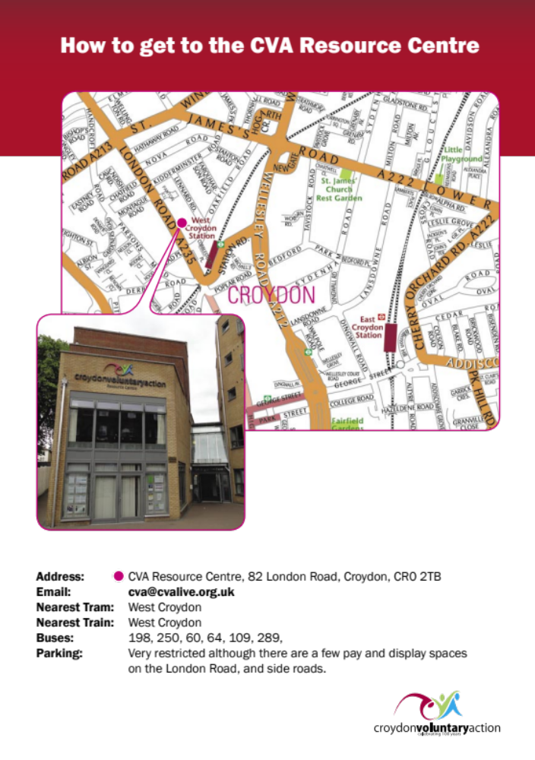



Conference & Meeting Room Booking Form

Name of Organiser:

Company:

Address:

Invoice Address: (If different from above)

Reference/Purchase Order Number (To Go on Invoice if applicable):
Contact Number: E-mail Address:
Date of Event: Start time: End Time:
Event Title:
Name of Contact on the day:
Numbers attending (including speakers):
Please tick below the rooms required for your event***:
Fill in any refreshment times in the box below (prices attached):

Training Room
Conference Room
ICT Suite
Boardroom
Crèche
Laptop(£10)
Projector(£10)
Flipchart
On arrival
Mid morning
With lunch
Mid Afternoon

***Please see terms and conditions. Subject to resource availability.
Please note there is an additional cost for equipment.
Our building has disabled access to all rooms and facilities however please let us know in advance if any member of the party has special requirements or requires assisted access.

SIGNATURE: DATE:

Signing this form confirms you have agreed to Room booking terms and conditions.
Please return this booking form to: CVA Resource Centre, 82 London Road, Croydon CR0 2TB or by e-mail martin.pritchard@cvalive.org.uk

CVA
Room Hire Terms & Conditions

- All prices are exclusive of VAT which will be charged on all bookings.
- A standard full day booking is from 9.00 – 5.00pm.
- A standard half day booking is 4 hours.(includes set-up and set-down – if you book a room from 12-16.00 you will not have access before 12)
- Rooms must be vacated by the end time given on the completed booking form (unless otherwise agreed with the CVA staff). Room use in excess of pre-booked times will be invoiced at the appropriate rate. When you have finished using our room(s) please ensure it is left clean and tidy.
- Any electrical equipment brought into the CVA must be PAT tested in advance (and have a label on the plug to show this).

Bookings & Fees
- Requests made for bookings more than 6 weeks in advance can be held provisionally for a maximum of 2 weeks after which they will be cancelled
- Requests made for bookings 1-4 weeks in advance will be held provisionally for a maximum of 3 working days. They must then be confirmed or cancelled.
- Bookings made within one week of the event will be invoiced in full at the time of booking. Any additional charges will be invoiced after your event.
- Out of hours use of rooms is subject to resource availability and prior agreement of CVA Staff.
- Once a booking is confirmed our cancellation fees apply, please see below.

Cancellation Fees
- Cancellation within 31+ days – no loss
- Cancellation within 1-4 weeks prior to event = 50% of the room hire fee.
- Cancellation within seven full days prior to event = 100% of the total invoice

To discuss your requirements or to view our facilities, please contact CVA on 020 8253 7060 or by e-mail at martin.pritchard@cvalive.org.uk you can also view photographs of our rooms on our website:
www.cvalive.org.uk

CVA Conference and Meeting Room Hire

CONFERENCE ROOMS | MEETING / TRAINING ROOMS
- Electrically controlled screen  - Wi-Fi connection available.  - Mobile Flipchart stands | - Internet connection  - Laptop connection  - Ceiling mounted Projector  - Whiteboards/Flipchart

Layout Styles  (please note, it is your responsibility to set the rooms up in your choice of style, rooms need to be returned to original setting after the event) | Training Room | Conference Room | ICT Suite | Board  room | Crèche
Capacity | 20-25 | 80-100  40 (Upper half)  35 (Lower half) | 10 | 20-30 | 12-15
Prices Full Day | £104.00 | £250.00  £140  (Upper & Lower) | £104.00 | £104.00 | £70.00
Prices 4hr session | £52 | £125  £70  (Upper & Lower) | £52 | £52 | £35
Sports & Leisure  (Hourly Rate) | £25 | £25 | £25 | £25 | £25
Evening Hire  Rate (after 5pm) | £35 | £80  £40  (Upper & Lower) | £35 | £40 | N/A

A4 Photocopying | A4 Colour Photocopying
8p per A4 side (1-100)  7p per A4 (101-500)  5p per A4 (500+) | 30p per A4 side (1-500)  15 per A4 (501-1000)  12.5p per A4 (1000+)
Tea/Coffee/Biscuits | £1.50per head
We pride ourselves on the excellent value for money offered by our facilities.

