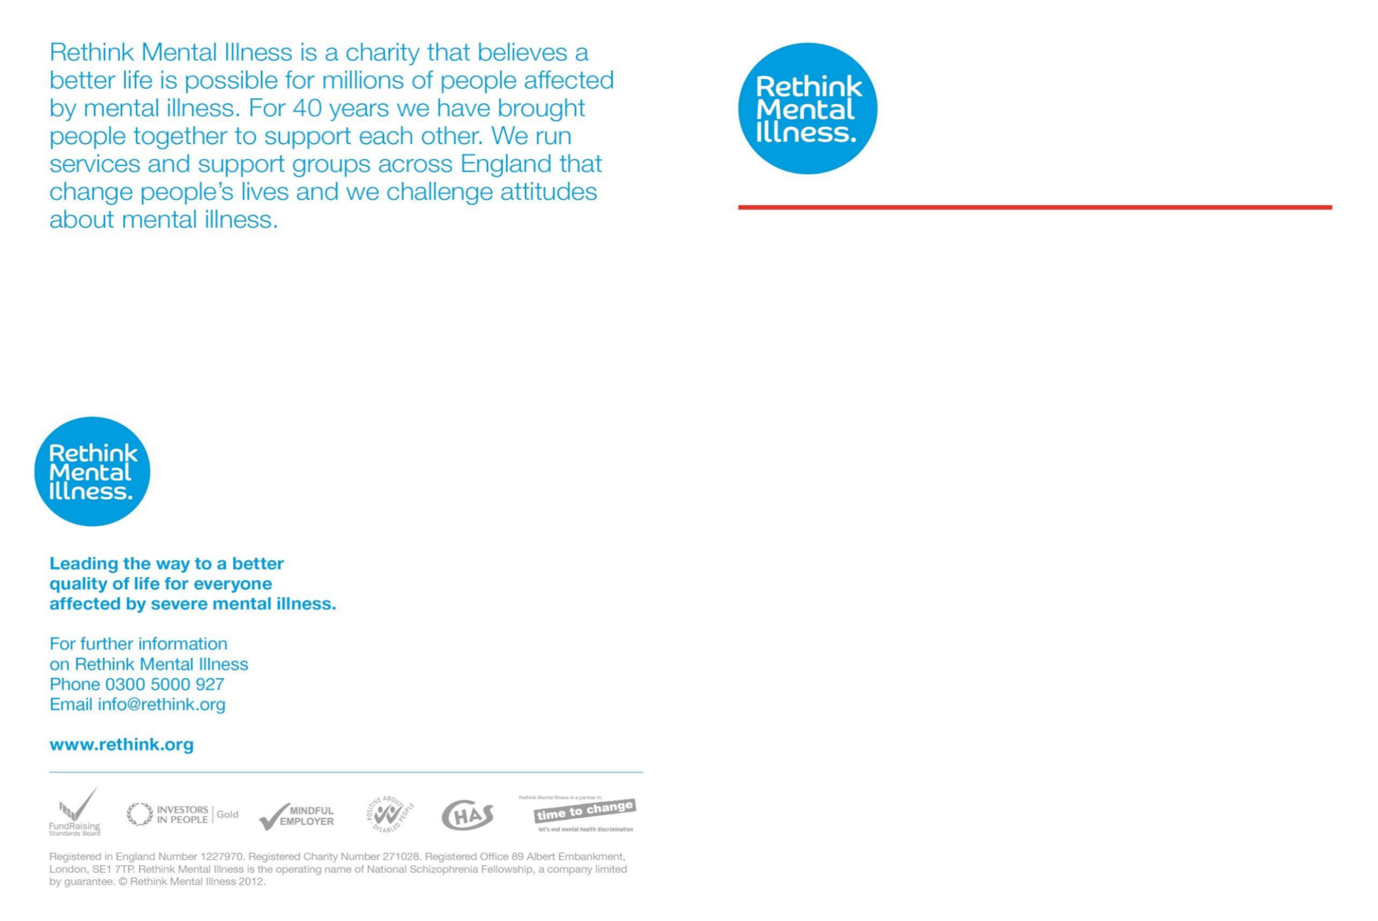

Croydon Rethink Carers Support Group
Care, Sharing, Support

Who we are
The Croydon Rethink Carers Support Group has
been established since about 1974,
providing help & support to carers of
those affected my mental illness.
All members are themselves carers,
and can therefore offer empathy &
help to those in a similar position.

“Are you fed up with ‘walking on
eggshells’ and would like to offload
and empathise with other carers?”

The group meets at:
Primary Room
United Reformed Church
Addiscombe Grove
(near East Croydon Station)
East Croydon
CR0 5LP

On the third Wedn-esday of each
month between 7pm – 9pm
Please ring bell if right hand door unattended

We love to welcome new members,
you can just turn up, but suggest
that before coming to the group,
you phone or email just to
introduce yourself and confirm the
venues’ location.

Please contact:
One of our members on
Tel: 0208 6603746
Email: ireneoliver77@aol.com

--------------------------------------------
'Many Rethink mental illness groups are run by people
with lived experience, carers or family members. Group members listen and share experiences but do not give advice. Groups may provide details of agencies whose
role it is to provide advice.'
Our Rethink Mental Illness Advice & Information Service can help with a wide range of issues affecting people with mental illness, their family, friends and carers including fact sheets – please call 0300 5000 927, between 9.30am – 4.00pm, Monday – Friday (excluding bank holidays), or visit our website
www.rethink.org
For free factsheets visit www.rethink.org/factsheets
or contact 0300 5000 927

