Local Community Partnership, Croydon South East
21 September 2023 – Meeting Notes

Dear Croydon South East Colleagues,

With thanks to Family Centre Fieldway for hosting the event and to our Co-Chairs, Marion, Roy and Julia, for their leadership.

Youth Violence
Our partnership met in the days following the murder of 20-year-old Bradley Hutchins, killed in a double stabbing at North Walk in New Addington near Family Centre Fieldway. A couple of partners in the room knew Bradley and his family and the shock and senselessness of his murder was shared by all. Testimony was given to local groups who were quickly on scene at the time to support the community, including Play Place, PY4E, Ment4, Parental Army and Family Centre Fieldway. The Centre of Change and St Christopher’s have since been offering talking therapy support. Centre of Change offered support and space for people to grieve/process. The Police Family Liaison Officer was relaying what the family want in terms of a community response, including the vigil.
The partnership heard from those who had attended the ReNA meeting earlier in the week and the discussion there on the erosion of youth services. Those involved in this double-stabbing are 20 yrs+, we discussed the lack of activities and opportunities for this age group. We heard that some in this age group think, "Only Fans is their only way to get out". Clearly better opportunities are needed for young people and this will be captured within our Community Plan.
Stronger Together
Stronger Together is the partnership that has formed from our Community Partnership meetings and has been awarded funding through the new Localities Commissioning Funding. The lead organisation is Centre of Change with the following partners: New Addington Good Samaritan Pop-In, New Addington Pathfinders, Good Food Matters, Selsdon Contact and The Family Centre. Sustaining NA Good Samaritans Pop In- Voluntary and Community groups across the locality are joining up services to sustain valued activity and extend their collective reach. Utilising existing assets such as Selsdon Contact's minibus and GFM's healthy eating and growing space.
In strengthening connections across the locality, Marion and Kirsty from Pathfinders visited Selsdon Contact. Selsdon Contact has since identified a new volunteer who will best help the partnership by being based at the New Addington Pop In.
Proposal to have a 'Community Army', like the 'Parental Army', growing a network of support in the community. Jarmila at St Christopher's keen to help to start.

SAVE THE DATE- Showcase event
Following the recommendation of the funding panel successful initiatives from across Croydon will be showcased at an event in Braithwaite Halls on 27 November, 10.00 - 12.00. The event will raise the profile of our partnership work and seek to gain further involvement in local initiatives. Commissioners, Councillors, LCP members will be attending.

Community Hubs
James Moore, CVA's Community Facilitator, and Roy Simpson, LCP Co-Chair and Community
Hub Team gave an update 14 months on and shared this well received film:
https://www.youtube.com/watch?v=FQ7fQaX5vHA
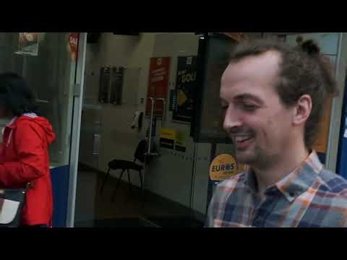 | The New Addington Community Hub  Thanks to our Lottery-funded Healthy Communities Together programme, Croydon’s Community Hubs are developing the capacity to achieve their full potential! For CVA, that potential is measured by the number of people we support to become active in their community. Watch this video to see what that means in practice:
Discovering what’s strong, not what’s wrong- strength-based training
Andrew Slegg and Sarah Burns are delivering training on ‘How to have a strength-based conversation.’ To help us take a person-centred approach and focus on what’s strong instead of what's wrong. These workshops help to put theory into practice and are for all working on the frontline. To book your place, click the following links:
Wednesday 11 October 10.30- 11.30
Book your place: CVA Eventbrite Discovering whats strong not whats wrong
Tuesday 7 November 13.00- 16.00
Book your place: CVA Eventbrite Discovering whats strong not whats wrong
Thursday 7 December 13.00- 16.00
Book your place: CVA Eventbrite Discovering whats strong not whats wrong

Community notices:
EMHip- new service
We were joined by members of Croydon's BME Forum who are working on the new MHip programme. The team are looking to provide early intervention for 11–25-year-olds by providing one to one casework following a referral with parental consent. Marion at Pathfinders to connect the team into schools. Diane at Centre of Change already supporting. Pathfinders offered for the new team to make use of their central space as a drop in on Tuesdays/Fridays. Amanda at GFM to link up the team with Kelly at Legacy.

Sexual Health
Low take up of service to date but the health statistics show that there is need for advice and information. Pathfinders suggested the service is offered on their FaceBook page. Suggestion to connect with Croydon Drop-In (CDI) at Central Parade, there's a big footfall between 3-4pm weekly and that's where the Talkbus position their service.

Autism youth group
GFM hearing about the demand for this and looking into linking up activity. Contact: amanda@goodfoodmatters.org.uk

Thank you for attending our first meeting back. Exciting progress and ideas to be worked out. We look forward to celebrating more work when we meet again. Save the date Thursday 23rd November for our next meeting
To book go to Eventbrite Local Community Partnership, Croydon South East .

Warmest Wishes- Roy, Julia and Marion

c/o Sarah Burns
Director of Communities
Croydon Voluntary Action
Mob: 07540 720106
Email: sarah.burns@cvalive.org.uk
CVA Resource Centre
82 London Road, CR0 2TB

