Local Community Partnership notes NW – Haslemere Hall 19.06.2025
Dear Friends and Colleagues of the North West Partnership.
Thank you for joining us.
We were glad to be able to show you the asset that is Haslemere Hall that have a plethora of rooms for hire and are very much community facing. To see what’s on and to hire Haslemere Hall click here: https://www.haslemerehall.org/
Paul Voden sent his apologies as he is on holiday.
Janet Cambell announced she would be stepping down from duties as co-chair but would be very much involved with the work of the NW area in her other capacities.
A thank you from Sarah Burns, on behalf of all of the Local Community Partnership stakeholders, for all the hard work Janet has done.

There is now a post vacant alongside Paul Voden, we are inviting expressions of interest to build on the relationships and partnerships formed at this local community partnership.
If you are interested in learning more please contact sarah.burns@cvalive.org.uk

Who’s in the room
Holmesdale community gardens are looking for planters which can be accessible to people of all abilities and where everybody can contribute their skills – whether that’s painting, sanding, cutting, drilling. They’re growing herbs and teas which to sell to get people thinking more green and spending less. They will be taking their herbs and teas to Croydon Festival.
Inaspectrum is a new and vital growing community of people affected by an aspect of autism. An association of like-minded people who wish to be contributors in their world, rather than consumers of another world. This group is not only open to people who have or feel they have autism but to people who have an interest in people with autism.
Creative health Croydon - funded by public health using arts to support health in the community. Creative Health Croydon provide ‘Croydon Loves You’ grants and run regular network meetings. £120, 000 in funding has been given away already. 60k is still available in different tranches for small-medium sized projects, with another round of funding opening up in September with available grants of up to 5k.
Sister circle, based in north east London are expanding their flagship programme into Croydon. They provide support networks for preganant women who are fleeing domestic abuse or don’t have support networks. They have 1-to-1 programmes offering vital practical and emotional support from trained volunteers. They are currently recruiting volunteers with training starting in September to start delivering in October.
Adult health and social care discussion around an emphasis to demonstrate what preventative measures have been explored as a first step with residents – for example exploring which community groups a resident might want to be connected to improve wellbeing and safety.
Croydon Alms Houses provide grants via their Croydon Relief in Need fund – Their funding priorities are 40% to help older people, 60% to areas of disadvantage. Grant application must fit in line with Croydon Alms Houses theory of change outcomes – which are centred around health and wellbeing and people managing their own lives.
Suggestions were made for future agenda items from funders and commissioners to hear about different projects they’re currently funding, showcasing and hearing about what works and what doesn’t. Making groups aware of other funding opportunities, and groups looking for match funding.
An idea for a ‘Meet the Funder’ themed LCP was suggested.

Meet Roz, new Community Builder for the North East and West localities.
We are really excited to announce the appointment of our new Community Builder, Roz Thornton.
She has a wealth of experience encouraging people to develop their skills and develop their own community projects that last.
She has also developed programmes within community centres across London and helped groups to build capacity and now, as a Selhurst resident, it's time to come home!
As Community Builder for the North she will work working between West Thornton and South Norwood, connecting the dots in between.
She will be working alongside the co-chairs for both the North West and North East localities (Janet Campbell, Paul Voden, Nicole Godetz and Magdalene Usikaro) to ensure groups are aligned to the local community plans the voices of the community truly feed into these.
She will be supporting activities around and within the community hubs in the north of the Borough and importantly be part of a Borough-wide team of community builders lead by Croydon Voluntary Action.
Front and centre, however is to understand the needs of our residents and the groups and support them to make their own changes to the community they live in.
If you'd like to connect, know a resident with an idea or, as group, feel you could be supported to connect to each other then please get in touch.
Email: roz@clearcommunityweb.co.uk

Update from SNT
Our colleagues from the MET police were unfortunately unable to join but have asked us to share the following update on the use of Live Facial Recognition in Croydon.
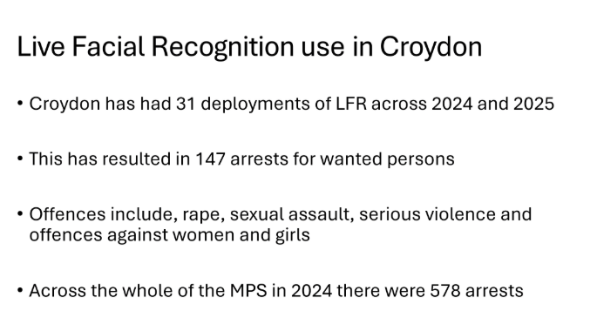

CCW Intergenerational 2.0 Program information and update
Digital Ambassadors
ClearCommunityWeb have been running a Digital Ambassador programme for over a year which provides work experience and placements for Young Adult who either live in Croydon North West or support projects that are based within the Locality.
This time last year they worked with Reaching Higher who ‘took over’ Digital Drop-Ins at Age UK Croydon, sharing experiences with their elders. They also had placements via Roehampton University and Queen Mary University who help support vulnerable residents via the Brigstock Road Hub, Thornton Heath Library and Central library to access services online and well as to be signposted to health and wellbeing support.
Overall CCW worked with 15 young people who, without exception thrived in developing their confidence and communication skills which were unexpected outcomes for all of them who initially expected to be able to demonstrate technical over personal skills.
One of the placements has subsequently progressed to being a Police Community Support Officer (PCSO) through the confidence gained from the programme.
Since November they have develop our programme to its second phase and worked with a cohort of placements 2 days a week both supporting session and residents at Age Uk Croydon, Norbury Library or Central Library as well as working on projects to support the organization and getting work-based skills.
Within sessions they have learned principles of active listening, safeguarding, data protection, basic administration and support as well as working on individual projects that have supported the organisation to complete a data migration project, conduct focus groups and measure impact as well as social media.
One of the placements ran a focus group and series of filmed interviews with residents within Drop-in sessions to understand the impact they have made on their lives, the journey they have travelled as well as the social connections they have made.
Omowumi, who couldn’t be here tonight, has lead on this project and now coordinates the session at Age UK Croydon, taking a lead on welcoming residents and introducing them to the volunteers and is now in a paid role until the end of the summer.
ClearCommunityWeb will compiling this into an exhibition over the summer and will have a celebration event and film night to celebrate the various projects that the residents themselves have been involved in through the connection and support they have made in these sessions – which includes the writing of 2 self published books, a peer support group for men living alone in Senior Living homes and a knitting group .
The third phase to this project is currently under review …… To be revealed!
--
ClearCommunityWeb are inviting anyone who is interested to attend a Cyber Awareness day on the 22nd July at Braithwaite Halls, St Katherine st. 6.30-8.30pm
This event is being organised by ClearCommunityweb and the Neighbourhood Watch. The police and Council will be in attendance.

Neighbourhood Networks of Support
Peer support in serious illness, loss and Palliative Care.
Speaker: Rekha Vijayshankar, Specialist Palliative Care Lead, Rekha is a Churchill Fellow, and a visiting associate for UCL. The name of the Project is Neighbourhood Networks of support
Rekha spoke from personal experience and feels the current system needs to be more set up for person-centred care.
Rekha went from being a banker to caring for her husband who was diagnosed with a serious illness. Over the last 3 years she worked with Marie curie and was a palliative researcher.
Rekha Wants to work with local charities to exchange information, hoping that people can support each other and create peer support networks, which can be set up in the community. The vision is that any charities can train their participants.
Key points noted from Rekha’s experience and research
- Communities are frightened of the illness and treatment
- By the time they present to Hospices, their illness is very advanced.
- There needs to be more support in the community.
- Palliative care is not at the centre of Medics training.
- Communities who face economic deprivation are less likely to understand their care plan and have less agency over decision-making.

Rekha Vijayshankar is inviting Croydon residents and groups to engage with a critical piece of research and community engagement that she is partaking in collaboration with Croydon Dignatate.
These sessions will be held in person and the purpose is to engage with communities around palliative care including:
- Physical and mental signs of needing health care services
- What services are available
- The planning process for end of life care
- Comprehensive contingency plans
- Looking after YOURSELF as a carer

These sessions will go toward the University College of London.
This research is funded and it will be possible to offer vouchers for those residents who are able to share their time to support this research work.
There will be opportunities to learn about Croydon Dignatate and the wide range of networks in Croydon that are there to connect and support people in Croydon who are caring for people.
It is also possible to have sessions online please get in touch with Rekha.
rekhavijayshankar@gmail.com / 07807 08 42 52
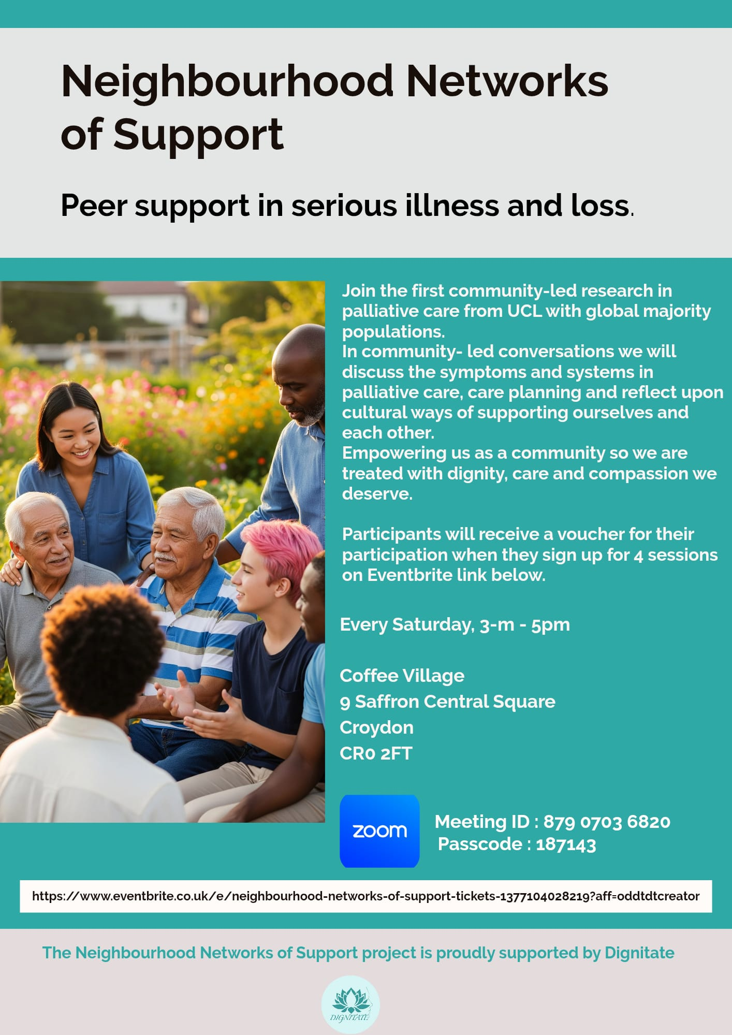

Thank you for attending and for a fantastic meeting for this locality. Thank you to the passionate residents and partners that make this good work happen.
Thank you to Janet for all her hard work and we will be sad to see her go but take comfort in the fact that she will still be around and supporting us in her other roles both as a councillor and active citizen.
We wish you a wonderful summer and we will see you in October.
Save the date: the next event is:
Thursday 2nd October 10am-12.30pm Venue TBC

Warm Wishes, Sarah, Andrew, James, Janet and Paul.

