South West London Voluntary Community and Social Enterprise (VCSE) Alliance
Terms of Reference:

THE SOUTH WEST LONDON VCSE ALLIANCE
The voluntary sector across South West London is organising itself into a ‘VCSE alliance’. Building on existing networks and forums, this alliance will become an established part of South West London’s integrated care system (ICS). Through this alliance, the voluntary sector will work in partnership with the NHS to tackle health inequalities and improve health outcomes. These Terms of Reference will adjust over time as they represent only the start of our journey, not the destination and our approach in this present moment.

- VISION
A positive impact in reducing health inequalities and improving the health and wellbeing of South West London residents through collaborative, innovative and sustainable approaches with the diversity of the VCSE sector reflected and embedded within all levels of the health and care system.

- AIMS
Our aims are to:
- To be a strategic link between the VCSE and other strategic partners within the integrated care system
- To be an enabler and a conduit for the development and embedding of robust partnership working within all levels of the new health and social care structures
- To facilitate understanding and shared learning and intelligence between sectors
Ensuring that:
- The VCSE plays a key role in the joint transformation of systems and services improving the health of people & communities.
- The full potential of the VCSE sector is maximised with the new ICS structures as a strategic partner and delivery partner to transform health and care services for local people.

- VALUES
Trust
To work with integrity, respect and honesty; and trust other stakeholders to do the same; to support change in working cultures within and between different sector partners.

Transparency

To ensure strong and transparent two-way communication within and between all stakeholders, including in decision making.

Innovative

To champion the VCSE perspective and breadth and depth of the sector to support new, creative ways of working that will challenge health inequalities and the wider determinants of health and wellbeing.

Collaborative

To establish shared goals between the VCSE and other key stakeholders to coproduce, develop and deliver innovative solutions, ensuring the VCSE is involved at every stage.

People and community focused

To ensure open and transparent communication with wider VCSE and local people and communities to ensure their voice is at centre of all decisions.

4 MEMBERSHIP
All 6 boroughs will appoint members onto the alliance whose responsibility will be to represent collective VCSE priorities. All 6 boroughs will base their representation on what’s working locally. As an example, Croydon is proposing to feed into the alliance through its HCT structures.

We’re building upwards basing this on local circumstances, what’s working, as an example of what this will look like across the system.

- THE DIRECTOR ROLE

The VCSE Alliance Director provides the mechanism to connect each borough to the South West London NHS system. A key aim is to enable programmes of work at a sub-regional level maintaining the borough perspective.

5.1 COORDINATING THE ALLIANCE
How we set up the Alliance across South West London will be dependent on local circumstances. Each borough has been inputting on how they see this working. To achieve this we will:

- present and invite input on ToR at relevant place boards
- host borough based sessions to engage the wider sector in Alliance development
- add capacity to the communications functions across SWL Leadership Group
- support the capacity of senior leaders to be able to engage in the Leadership group

APPENDIX 1: SWL VCSE STRUCTURE

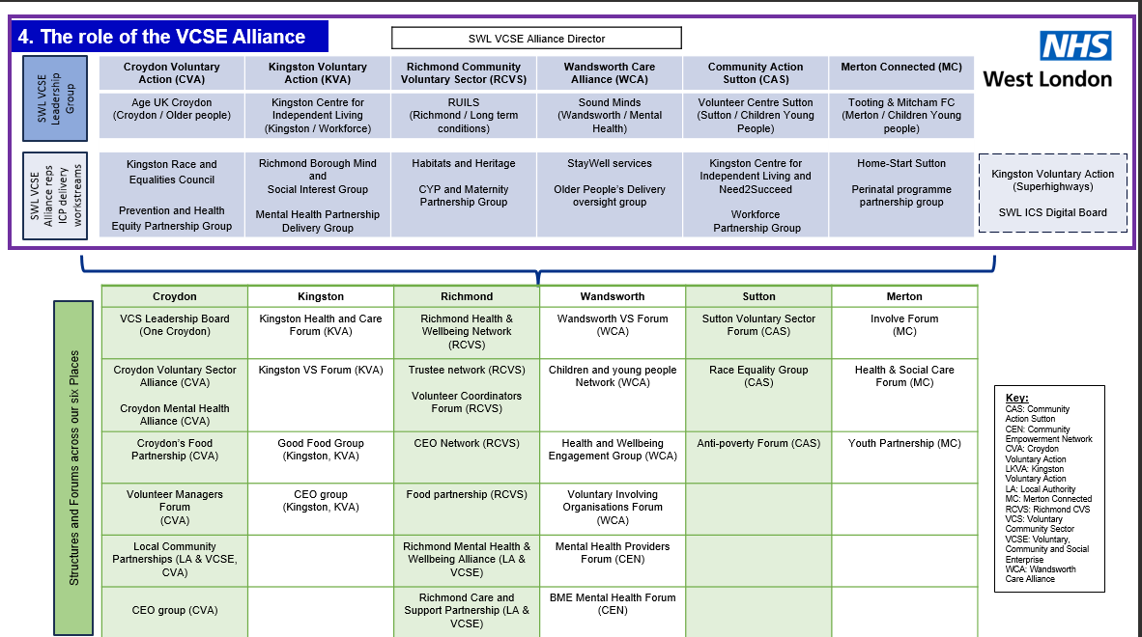

APPENDIX 2: HOW WE GOT HERE: BACKGROUND
Integrated care systems (ICS) were constituted on 1st July 2022. NHS England guidance for the implementation of ICS requires the establishment of a ‘VCSE alliance’, and targets to enable this have been set: (1)
“By [July] 2022 integrated care partnerships (ICPs) and the ICB are expected to have developed a formal agreement for engaging and embedding the VCSE sector in system-level governance and decisionmaking arrangements, ideally by working through a VCSE alliance to reflect the diversity of the sector.”
A collaboration of the six VCSE local infrastructure organisations or functions covering the six constituent southwest London boroughs (2) have been working on building a VCSE alliance, and the chief executives or equivalent of the six partner organisations have formed as an initial VCSE leadership group.

SWL VCSE LEADERSHIP GROUP
The six borough VCSE infrastructure groups have been fulfilling the leadership role in the development of the South West London VCSE Alliance. The Leadership Group plans to expand to include representation from smaller voluntary groups and provider organisations.

WHAT WE HAVE AND WHAT WE NEED (3)
The SWL VCSE Leadership Group commissioned a rapid review of VCSE networks and structures across southwest London(4). This revealed a great deal of existing good practice, almost entirely at place level, but also exposed some weaknesses. The research found that all the boroughs have assets that can be built on, although there is a lack of capacity to operate at system level, a lack of thematic networks and a lack of understanding in the statutory sector of the nature and scope of the VCSE sector.

The VCSE sector is intended to be a key strategic partner with an important contribution to make in shaping, improving and delivering services, and developing and implementing plans to tackle the wider determinants of health. We should be embedded in how the ICS operates, including through involvement in governance structures in population health management and service redesign work, and in system workforce, leadership and organisational development plans. We have the expertise to bring to this but lack the capacity. As a sector, we have depth of knowledge, insight, reach into communities and the ability to innovate. We are well placed to deliver on all four aims of ICS:

• improve outcomes in population health and healthcare
• tackle inequalities in outcomes, experience and access
• enhance productivity and value for money
• help the NHS support broader social and economic development.

“The VCSE sector brings specialist expertise and fresh perspectives to public service delivery and is particularly well placed to support people with complex and multiple needs. It has a long track record in promoting engagement and finding creative ways to improve outcomes for groups with the poorest health, making it an essential partner in combating the inverse care law. With its focus on early action, preventative services and wider social value, the sector provides good value for money. It brings insights, voice and assets into partnerships to support health and wellbeing, including expertise in service redesign and delivery, insight into inequalities, and access to volunteers and premises”
NHS England ICS implementation guidance

REFERENCES:

1 Building strong integrated care systems everywhere: ICS implementation guidance on partnerships with the voluntary, community and social enterprise sector, NHS England, September 2021
2 Community Action Sutton, Croydon Voluntary Action, Kingston Voluntary Action, Merton Connected, Richmond CVS, Wandsworth Care Alliance
3 Business case SWL VCSE post 1.6.22
4 “Building a voluntary sector alliance across southwest London: an analysis of existing networks and structures, their influence and potential”, Lev Pedro & Associates, March 2022

Date: May 2023
Reviewed: August 2024

