Croydon Central East Local Community Partnership - Co-creating the Community Plan

By November 2025, Seventeen ‘Local Community Partnership’ events had been held in Croydon Central East (which includes the Woodside, Shirley, Addiscombe East and Park Hill communities) involving people and communities.
In 2025 alone there were over 125 attendees from Voluntary and Community Sector organisations (50+), Community Groups and residents (45+) and statutory workers (25+)

Totaling 239 Voluntary and Community Sector staff from over 150 different Voluntary and Community Sector organisations.

Many of the phenomenal local assets in the area have been celebrated, the most valuable of which is the local people. A locally owned Community Plan has been initiated with input from 282 individuals living and working in the locality. For notes from previous meetings see the Locality Webpage: Local Community Partnerships - Croydon Voluntary Action (cvalive.org.uk)

Community Plans go beyond identifying need by taking an outcomes focused approach that identifies gaps. This Community Plan is live and evolving in the sense that key partners are working on actions that can be taken forward and making recommendations when further resource is needed.

Priorities for Croydon Central East have been summarised in the table below:

Community Plan for Croydon Central East, October 2024

 | Key themes & Outcomes | Co-production in design & delivery | Current Activity | Evidence base | Alignment | Filling the gaps  -What needs to happen
1 | Community Hubs  Healthy, safe and well- connected neighbourhoods and communities* | Floating Counselling Support Celestina worked with the Social Prescribing Link Worker Lynda to set up the hub to co- designing ‘Woodside Community Hub’ | Woodside Community Hub  A central gathering place based at Woodside Baptist Church for residents and the community to "thrive not just survive". Volunteers and residents come together for a tea and a chat. The Hub is supported weekly and from time to  time by: | Project evaluation using Upshot- quarterly monitoring reports to OCA quantitative (incl. SMART outcomes data) and qualitative (incl. change  stories) | Joint Local Health & Wellbeing Strategic Plan 2024/29 (Priority 3)*  ‘Our Community Hubs offer holistic support to our communities..  and are a place | Sustain ‘Woodside Community Hub’ for community use  Sustain/create community-led activities

 | Increased independence  Improved mental and physical health  Increased social contact and community support | Ongoing community engagement needed  Ongoing interconnection with all stakeholders incl. VCOs and NHS using, NHS England » You said, we did  More work needed with Health professionals to enable effective co- production | - NHS Link Worker  - Floating Counselling  - Clear Community Web  - Age UK Croydon  Open every Tuesday Time: 12.30 to 2.30pm. Monthly Last Tuesday of every month, Health and Wellbeing event. www.floatingcounselling.co.uk/wch  Other potential hubs incl: Waterside Centre Zaian Youth Centre and Shirley West Wickham Baptist church  CrESNT partnership:  Heat & Eat Food poverty support at Woodside memorial Park on Every Thursday 4-5pm  Elderly support  Welderlies Warm brunchette at Ashburton Café and  Woodside Pop In  Mental Health Online and in-person Floating Counselling  Internet inclusion fortnightly by Clear Community Web  Transportation Dial-A-Ride, Blue badge support, food delivery  Male Mentoring Support Holistic Wellbeing Hub (HWH) | Joint Outcomes and Monitoring Framework with key performance indicators to track progress towards our goals  Key performance indicators - align with the indicators identified for the JLHWB strategy and JOCM  -Joint outcomes framework and data group to follow  Indicators incl., sense  of belonging, social cohesion, social trust | for our residents to meet and connect with others.’  Croydon Council adopted NDTi Community Led Support Resource Wheel incl:  ‘Strength based conversations’  -ASC  Transformation Plan, Newtons | Create volunteer/work opportunities  Identify and enable Community Hubs to be run as self-sustaining commercial ventures – owned and run by local people. Such as re- opening libraries to continue/expand a program of activities tackling critical issues such as fuel-poverty and health-inequality.
2 | Heating & eating  Cost of living: supporting our residents to ‘eat, sleep and have heat’ | Lead partners providing poverty support incl. Floating Counselling, Healthy Homes and Citizen’s Advice Croydon (CAB) have inputted  into LCP | Floating Counselling provide food poverty support at Woodside Memorial Park on Every Thursday 4-5pm. Contact, info@floatingcounselling.co.uk  Food at every CrESNT project delivery | Upshot- quarterly monitoring reports on LCM to OCA quantitative (incl. SMART outcomes data) and qualitative (incl.  change stories) | Joint Local Health & Wellbeing Strategic Plan 2024/29 (Priority 2)  - ‘around 1 in 3  children under 16  years of age lived | Borough wide strategy for food security  Projects to increase donations of food and essentials, volunteer recruitment & co-  ordination (incl.

 | Increased independence  Improved mental and physical health  Increased social contact and community support | Health & Wellbeing Survey of LCM partnership activity underway | Winter packs provided as part of CrESNT partnership (incl. water bottles, radiator bleed keys, gloves, winter hats)  100 therapy Psychotherapy 121 session for residents  Monthly health and wellbeing workshop at the community Hub, last Tuesday of every month  Food Roots- small funds to sustaining and growing food  Housing Officer From BU Support & Floating Counselling, Healthy Homes attends the Woodside Community Hub | Upshot- H&WB Survey results  Joint Outcomes and Monitoring Framework with key performance indicators to track progress towards our goals Indicators incl. % households in fuel poverty, % unemployed and claiming benefits and childhood obesity indicators for year 6  The 2021 research found that the annual cost to the NHS of leaving people in the poorest housing was around £1.4 billion. In addition, when wider societal costs are included, it was estimated that the full cost to society of poor housing was £18.5 billion  per annum. | in poverty (Child poverty rates, 2021/22).’  Work with the H&WBB to establish a ‘Cost of Living Action Group’ | refrigeration and storage), education to reduce stigma  Gardening clubs, cooking on a budget  More specialist IAG to enable people to access support and benefits they’re entitled to.  Training & resources on accessing Information Advice & Guidance (IAG)  Crisis Fund v. small one off contributions  Community-led peer support groups  Tackling the root causes of fuel-poverty by improving the fuel- efficiency/dependency of housing.

 |  |  |  | BRE_cost of poor housing tenure analysis 2023.pdf
3 | Later Life  Supporting our older population to live healthy, independent and fulfilling lives*  Increased independence  Improved mental and physical health  Increased social contact and community support | Lead partners such as: Floating Counselling Support, Welderlies, AUKC, CNCA, Shirley Neighbourhood Care Assoc.(SNCA) and Addiscombe Neighbourhood Care Association (ANCA) have fed into LCP plans  H&WB Survey underway of LCM funded partnership | Welderlies warm brunchette at Ashburton Café  Woodside Pop In  Visiting schemes/lunch clubs including SNCA and ANCA  Befriending schemes to connect isolated into community life are oversubscribed at AUKC, CNCA and CVA  Accessible transport, Dial-A-Ride, Blue badge support, Croydon Vision mini-bus  Posters/flyers/in-person events inviting people into community life & the 5 ways to wellbeing are ad hoc  ClearCommunityWeb (CCW) at Community Hub to support people to learn to use technology  Dementia Friendly Borough, Memory Tree Café’s  Community Champions- Mutual Aid/door knocking to connect people to | Joint Outcomes and Monitoring Framework with key performance indicators to track progress towards our goals Indicators incl:  Quality of life in older people, admissions due to falls | Joint Local Health & Wellbeing Strategic Plan 2024/29 (Priority 5)*  Croydon’s Proactive and Preventative Care Model  Population Health Management Programme  ICN+ Programme  Croydon’s Dementia Strategic Plan | Sustain groups that are enabling people to keep independent  Befriending projects to be sustained, co- ordainated  Gap of those that fall outside of criteria  Coordination of activities/ support communicated in flyers/posters in public spaces  Sustain opportunities to learn technology incl. social media  Sustain and incr. dementia support such as Memory Tree Cafes  Coordination of neighbourhood groups to  connect people into

 |  | By 2035, over a fifth of UK residents will be aged 65 and over, and by 2050, that proportion will be almost a quarter.  Asking middle-aged residents how they would like Croydon's buildings and places to ‘serve’ them in 2050. Engage stories and needs of current older residents to identify their needs and help plan for better outcomes for the next generations. Pathways- to-Healthy-Ageing.pdf | local activities/support through neighbours. Good practice being shared. Contact info@floatingcounselling.co.uk  Specialist Information, Advice and Guidance (IAG) provision  Carer Leaders – running weekly elderly support group and starting a befriender peer to peer support group |  |  | community life incl. Mutual Aid groups, Residents Associations, PTAs, Scout groups  More specialist IAG provision needed, incl. in-person IAG  Develop intergenerational initiatives to improve the quality of buildings, places and placemaking
4 | Mental health & wellbeing  Good mental health and wellbeing for all*  Increased independence | Lead partners incl: Mind in Croydon, Croydon Drop In, Off the Record and The BME Forum and Floating Counselling have inputted through the LCPs | Safe spaces for people to access preventative support in the community. For Mental Health Alliance contact, steve.phaure@cvalive.org.uk  Activities that help with self-regulation, incl. Floating Counselling  Link to list of activities/opportunities | Upshot- quarterly monitoring reports to OCA quantitative (incl. SMART outcomes data) and qualitative (incl. change stories)  Joint Outcomes and Monitoring Framework with key performance  indicators to track | Joint Local Health & Wellbeing Strategic Plan 2024/29 (Priotity 1)*  ‘..improving, protecting and promoting our mental health and wellbeing at the | Safe spaces for people to access preventative support identified, sustained and strengthened  More activities that help people to self-regulate, prevent crisis  Coordinate best use of people who are trained

 | Improved mental and physical health  Increased social contact and community support | H&WB survey of CrESNT participants is underway | Mental Health First Aid (MHFA) and Trauma training for community members  MHFA/Trauma informed training  Work to de-medicalise death, dying and loss and other health related concerns, once a month workshop to begin December ay Woodside Community Hub, Every First Tuesday of every month with Floating Counselling and Dignitate | progress towards our goals e.g. Indicator - loneliness and isolation  Active Minds Evaluation | centre of our actions’.  Mental Health Transformation Programme  South West London Mental Health Strategy | in MHFA and Trauma for pro-active ways of working  MH Awareness Training for partners/residents  Arts and creative approaches to contemplate existential themes  Creative solutions to be inclusive incl. informal, safe activities  Tackle anxiety and stress of housing issues.  Improving energy efficiency of homes to need less heating relieves fuel cost pressure and health concerns (cold and mould).
5 | Young people  Supporting our children, young people and families*  Increased independence | Reaching Higher’s survey results  Engagement with Oasis Academy  Floating Counselling and HAF organisations in Croydon 4-16 year  old | ‘Croydon Model of Provision’ Schools/Colleges to connect to mentoring, sports, arts, environmental activities. Contact: Steve.Phaure@cvalive.org.uk  Access to physical and mental wellbeing activities Link to list | Upshot- quarterly monitoring reports to GLA as above  Joint Outcomes and Monitoring Framework with key performance indicators to track progress towards our goals | Joint Local Health & Wellbeing Strategic Plan 2024/29  (Priotity 4)*  ‘9,041 7-to-16  year olds were estimated to have a probable mental disorder in  Croydon (Mental | Sustain/create spaces and access support for young people.  More accessible physical and mental wellbeing activities catering for diversity of young people.

 | Improved mental and physical health  Increased social contact and community support | Online Parenting group lead by Floating Counselling Psychotherapist and relationship coaches and SEND specialist  Holistic Wellbeing Hub father/ son Jujitsu in Addiscombe  Floating Counselling and Wellbeing You do yearly intergenerational projects and Skibabble, Floating  Counselling and | Police holding a series of safety events  Intergenerational activities with Woodside Pop In and young people, insights from CB, “using spoken word open mics to provide an outlet for non-  violent communication for the youth as well as a space to improve relationship  with older people and the police.” | Indicators incl. self reported wellbeing, self harm/ suicide  South London Partnership identifies the skills and employment opportunities involved in retrofitting our existing buildings for climate resilience, health and net-zero as a £17b economic opportunity. Retrofit skills, Home - Retrofit Skills Centre , Training, Courses | Health of Children and Young People in England Survey, 2023’  Croydon young people and families plan 2020/24  GLA ‘Young Londoners’ Peer Outreach Workers | Career guidance, employment and mentoring opportunities  Education/activities supporting young people to keep safe  Special Educational Needs support for families and carers  Support for families incl. support with challenging behavior, ‘connection before correction’  Volunteering/work opportunities  Green Skills economy  More accessible arts and creative opportunities needed

Wellbeing you have done intergenerational project in Autumn
2024
6 | Environment  Healthy, safe and well- connected neighbourhoods and communities*  Increased independence  Improved mental and physical health  Increased social contact and community support | Monthly Health and Wellbeing events at the Woodside Community Hub undertaking a H&WB survey  More outreach needed | ‘Friends of’ groups Career Leaders | Joint Outcomes and Monitoring Framework with key performance indicators to track progress towards our goals  2022 saw the hottest ever recorded temperature in the UK and Addington Hills caught fire.  Approx a quarter of CO2e emissions nationally are created by energy for our built- environment. | Joint Local Health & Wellbeing Strategic Plan 2024/29 (Priority 3)*  ‘Climate change is a global health emergency. While it has negative impacts on all of us, we know that it disproportionately impacts disadvantaged groups, who already experience poor health, exacerbating health inequalities.  Tackling climate  requires collective action’ | More work needed to sustain and develop green spaces for community ownership and activity.  More community-led activities in green spaces  Engage with Croydon’s climate action groups and coordinate initiatives and interrelated work streams. Adapt rather than demolish buildings and choosing bio-based and regenerative materials to build.

CHANGE STORIES:
CENTRAL EAST WOODSIDE POP-IN
Adrian had been coming to the Woodside community pop-in for a few months. At first he came to improve loneliness and isolation through socialising with his peers and having a warm space to be. Adrian was diagnosed with early onset of Parkinson's disease which he found very difficult news to adjust too. He didn't speak about his diagnosis with anyone it was only when his need for every day provisions such as s hopping became unmanageable he confided in some friends and Lynda at the pop-in, support which he hadn't found elsewhere. Even if he could access support it would be a struggle with his increasing physical limits. Adrian has described the Woodside pop in as a life line and the benefit of belonging at the Woodside pop-in invaluable.

J & D – Floating Counselling Food bank and Woodside Community Hub
I have had cancer 3 times, my husband 2 times, he just finished his chemotherapy a few months ago. Our son who lives with us in his 40’s has been sucidal with multiple health issues. We didn’t know where to turn when parking tickets and tv license scare letters was coming. GP referred me to speak to Lynda, she mentioned the Woodside community hub on Tuesday, but I have been so sick that I couldn’t attend the last 5 months, when I did attend I was too ill to stay to receive help, but I also attend the food Bank Celestina Runs on Thursday when I am feeling up to it, when ill she brings food box over so my husband and I do not have to make the journey. I told Celestina about my situation, parking tickets and tv license letters. Celestina sat in my garden with me after the food bank on Thursday to help me do my reapply for my blue badge and our tv license. My husband who is 90 years old and I have been trying to sort this out, plus all our health issues, for almost 2 years. We are so grateful for the work Lynda and Celestina do in the community. I can always call Celestina for help and she makes me feel like I am the only person she’s got time for.
When I feel better, I now volunteer at Celestina’s food bank, it makes me feel like a part of the community, I like giving back and helping others, when I am ill, it motivates me to feel better.

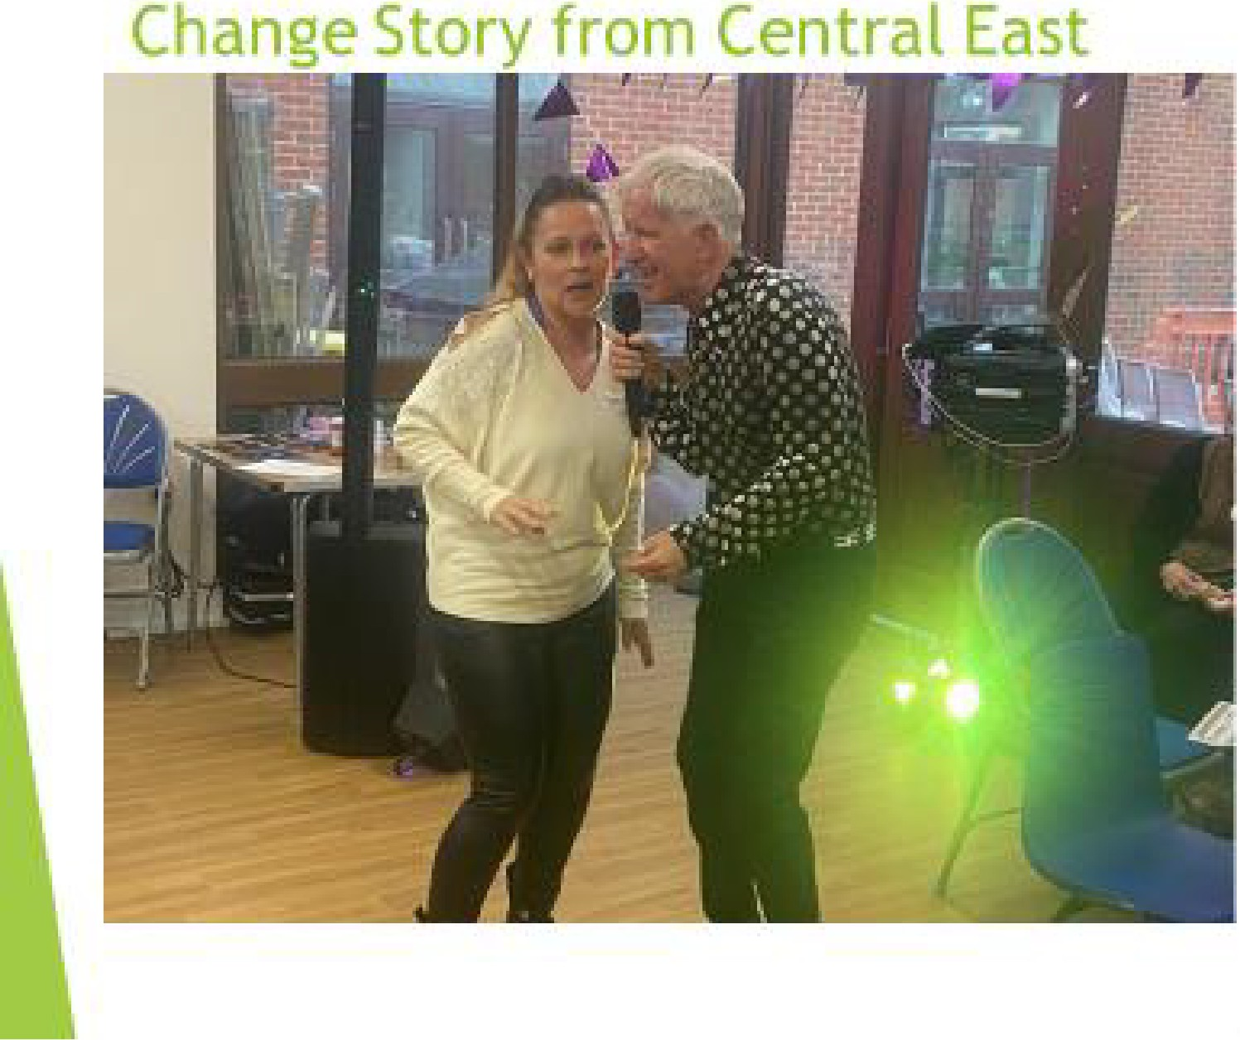



- v<
croyribli'YO'lu:t-f ryoctian

Steve Wa.lton's.a.L!ld o te
his 80 year old mumi Ma•.--•-> attending Woodside Pop 11.
- flndl'ng frlendships·and co. when she was isolated and l This changed her life

