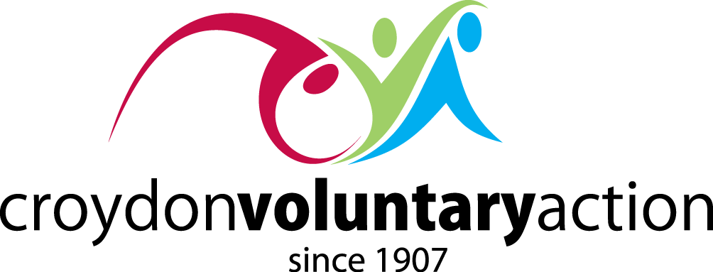
CROYDON VOLUNTARY SECTOR ALLIANCE
Thursday 22 October 2020
10.00 to 12.00 online

AGENDA

10.00 | Welcome and Introduction  - Steve Phaure, CEO Croydon Voluntary Action
10.05 | Croydon’s Finances Under Pressure:  Impact on Council services and what it means for Croydon’s VCS  - Gavin Handford, LBC Director of Policy & Partnerships
10.20 | Q&A
11.00 | One Croydon Alliance:  Integration, localities and community partnerships  - Rachel Soni, LBC Director of Integration & Innovation  - Jill Kyne, CEO Age UK Croydon  - Ima Miah, CEO Asian Resource Centre
11.20 | Q&A
11.50 | Plenary:  Working together in partnership  - Steve Phaure, CEO Croydon Voluntary Action
12.00 | Close

Please book your place here: Book now!!!!
With a maximum of 100 places, 1 per group - it’s first come, first served

