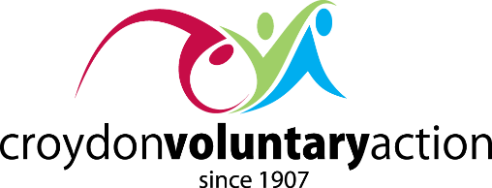

CVA COMMUNITY SHOWCASE & AGM
Thursday 21 November: 10.00am – 5.00pm
Croydon Whitgift Centre (near the Christmas tree)
AGENDA

10.00am Exhibition opens
- The 2019 Community Showcase

11.00am: The Croydon Partnership
- Hosting the event

1.00pm: Welcome from Sue Dzendzera (Chair CVA)
Guest speaker:
- Steve Reed

4.00pm: AGM Opening
- The Worshipful Mayor of Croydon, Cllr Humayun Kabir
- Steve Phaure (CVA Chief Executive)
Presentations:
- Rainbows Across Borders Choir
- Well Versed Ink
Guest Speaker
- Sarah Jones
Awards:
- Croydon Carnival
- Volunteer Centre

5.00pm: Close

