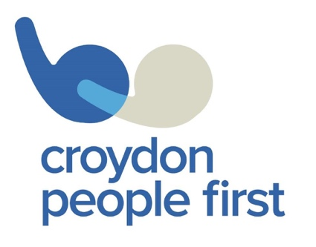

TIME CAPSULE
2020

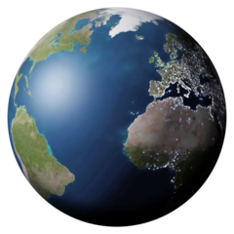

Name: …………………………………………………

page | title
3 | 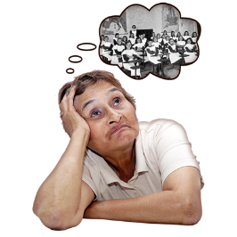 | Living Through History
5 |  | How I’m Feeling
7 | 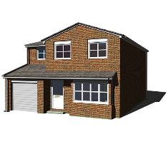 | My Community
9 | 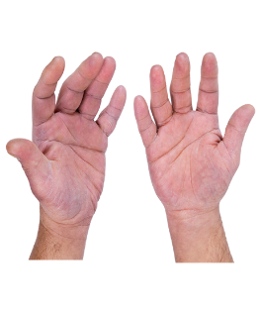 | Handprints
11 | 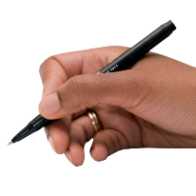 | Write a letter to yourself

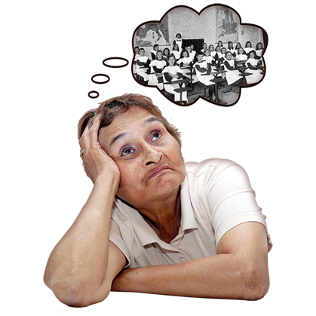
Living Through History

Take a moment to fill in these pages for your future self. Here are some ideas

Pictures from this time | Art work you created
A journal of your days | Family / Pets pictures
Newspaper clippings | Special memories

How I’m Feeling


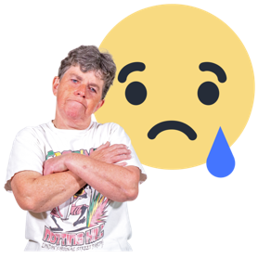
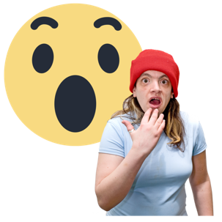


Words to describe how I feel

I’m most thankful for

----------------------------------------------------------------------

----------------------------------------------------------------------

----------------------------------------------------------------------

What I have learnt from this experience

-----------------------------------------------------------------------

----------------------------------------------------------------------

----------------------------------------------------------------------

3 things I am most looking forward to when this is over

1 | 2 | 3



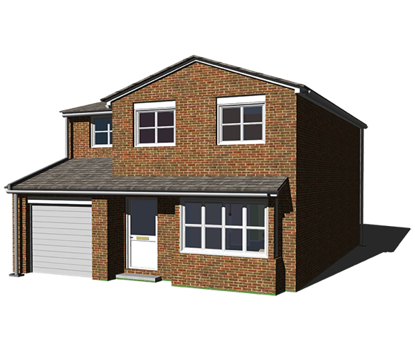

My Community

Draw your house or flat and colour

What it like were you are living?

What are you doing to connect with others?

You are not stuck at home
You are safe

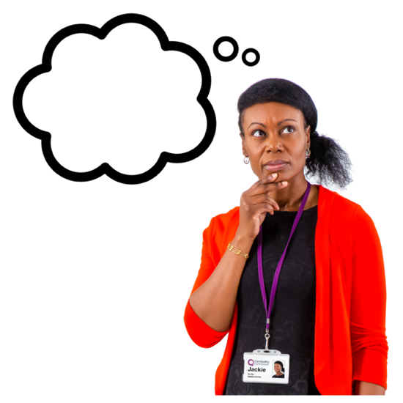
What are you doing to keep busy at home?

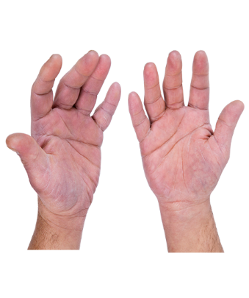
Hand Prints

draw round your hands

left hand

right hand
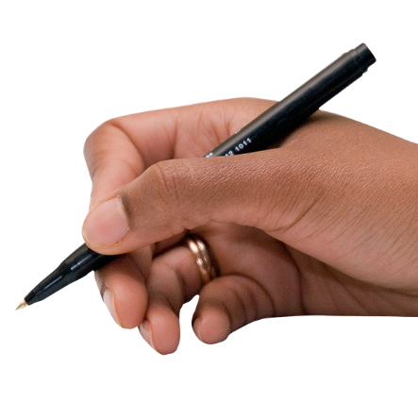
Write a letter to yourself

--------------------------

Dear

---------------------

-------------------------------------------------------------------------

-------------------------------------------------------------------------

-------------------------------------------------------------------------

-------------------------------------------------------------------------

What is a time capsule?

Somewhere to record your time in history
- what you were doing
- how you were feeling
- what your life is like in 2020

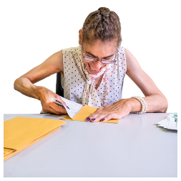
When you have filled in your time capsule find an envelope or a box to put it in

Hide it in the back of your wardrobe or under the bed or in a drawer

Don’t forget where you put it
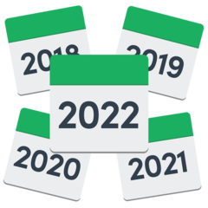
Decide when you want to open it and look back at 2020

Could be 1 year, 5 years, 10 years

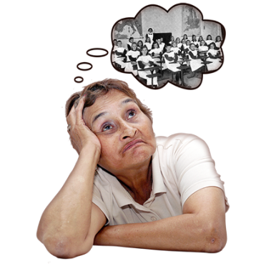
Have fun!

