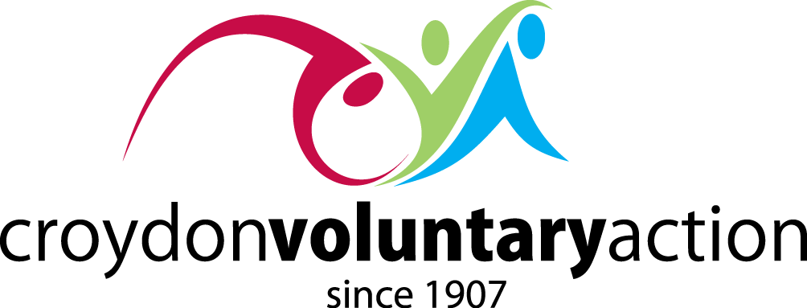

**CROYDON VOLUNTARY SECTOR ALLIANCE**

**CHAMPIONING CROYDON’S CIVIL SOCIETY**

**Meeting on Thursday 16 November 2023 - 10.00 to 12.00 online**

**AGENDA**

|  |  |
| --- | --- |
| **10.00** | **Welcome and Introduction**  Steve Phaure - Chief Executive, CVA |
| **10.15** | **Community-led solutions to tackling:**   * Food poverty - Julia Weller, Family Centre Fieldway * Mental Health - Gordon Knott, Croydon Drop In * Cost-of-living – Marion Burchell, New Addington Pathfinders |
| **11.00** | **Croydon Council’s Reset**  Councillor Andy Stranack - Cabinet Member for Culture & Communities, London Borough of Croydon   * Commissioning * Community Assets |
| **11.15** | **Questions & Answers** |
| **11.45** | **Consulting on CVA’s Strategic Plan**   * Give local communities a constitutional say in how Croydon is run * Give our local VCS an expanded role in managing Croydon’s recovery * Bring coordination and cohesion to VCS funding in Croydon |
| **11.55** | **Any Other Business** |
| **12.00** | **Close** |