
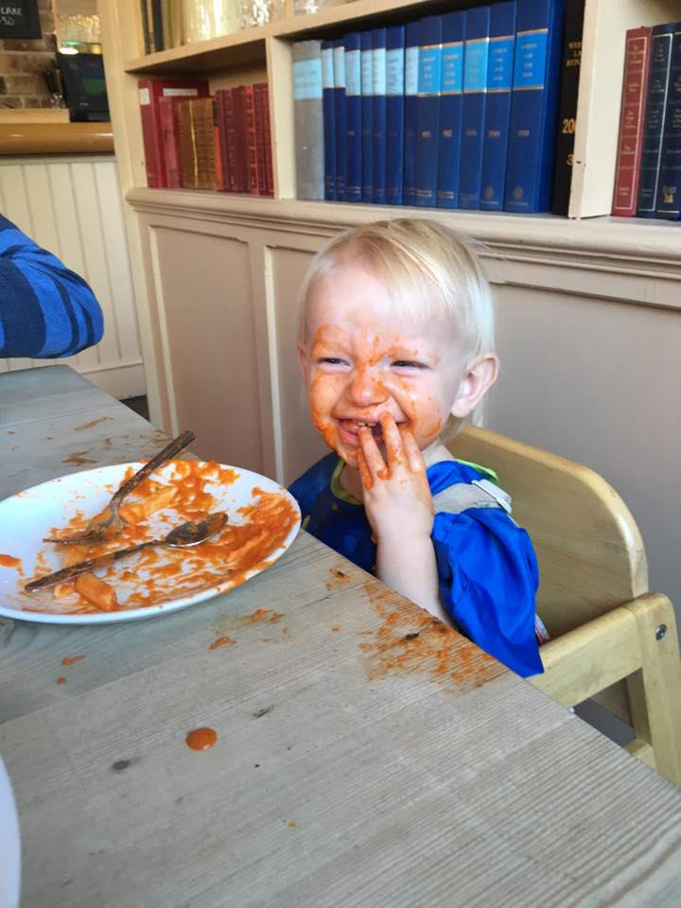
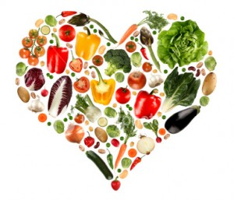
Find out how you can improve your families health by attending our informative and interactive roadshow. Talk to experts who can advise on healthy eating and lifestyles and find out about health information online.
You can also enjoy taking part in healthy eating craft activities and make fruit kebabs!
Healthy Lifestyles Roadshow for Families
with Croydon Libraries
Thursday 13th February 2020
10.00am-1.00pm
Free, just drop in!

Croydon Central Library
Katharine Street
Croydon, CR9 1ET
T: 020 7884 5140
E: croydoncentrallibrary@croydon.gov.uk

