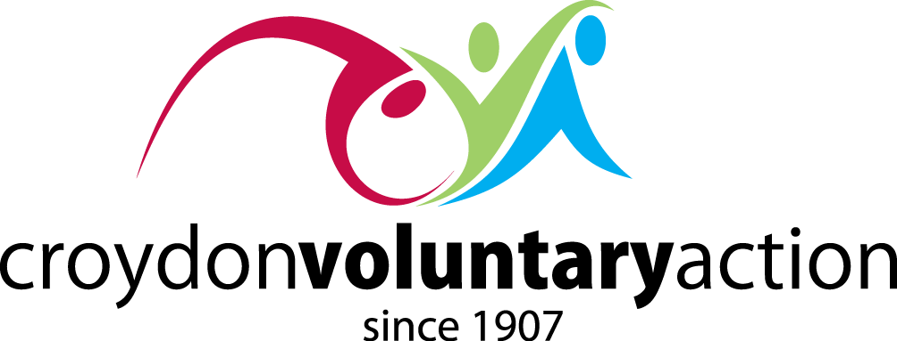

CROYDON COMMUNITIES RENEWAL PLAN
A STRATEGY FOR INCLUSIVE AND SUSTAINABLE GROWTH

Retaining the Vision of One Croydon

This statement of intent - to build on the legacy of 2020’s historic community effort in tackling the Covid19 pandemic – forms a joint voluntary and community sector (VCS) response to the Council’s public engagement on its savings proposals. It makes the case against cutting VCS activities and for the radical shifting of resources that Croydon’s Local Strategic Partnership (LSP) members subscribed to in 2020, in response to the game-changing impact made by Croydon’s VCS – not just in mobilising emergency relief support systems across the borough, but in demonstrating the VCS’ primary role in combatting the disadvantages exacerbated by Covid19. The intent we invite Croydon Council to share, alongside its requirement to repair the borough’s finances, is based on a faith in Croydon’s communities and a conviction that its VCS can deliver on the new Corporate Plan priorities to provide value for money and focus on tackling ingrained inequality and poverty.

The intent found in this Croydon Communities Renewal Plan goes further still – in proposing a community strategy for Croydon that places the VCS at the heart of a new operating model that delivers on the One Croydon vision of local people playing lead roles in their communities, with our VCS partners facilitating collaboration in our localities. This is a strategy that goes beyond recovery from the Covid19 pandemic and into the operational delivery of long-term plans for inclusive, sustainable growth in every community across Croydon.

Community-led Operating Model in our Localities

The huge impact made by Croydon’s VCS in 2020 was documented in the report - Covid19: The Croydon Voluntary Sector Response - shared with LSP members in July 2020. The report captured how VCS organisations led the way in mobilising volunteers, supporting mutual-aid and providing emergency relief, but also in finding community solutions to the pressures intensified by Covid19 on people’s family life, their mental health and their financial means. In doing this the VCS demonstrated the indispensable role it must play in a localities strategy that works to a simple rule – the more local the better. With their roots in local communities Croydon’s VCS groups innovated the agile and creative ways of working in 2020 that can define a new operating model for Croydon based on maximising the resilience and enterprise of our local communities.

Healthy Communities Together

Rethinking how we shape our localities amounts to systems change – which is exactly what Croydon has signed up to through the King’s Fund’s Healthy Communities Together programme. This programme invited bids to develop effective and sustainable partnerships between the VCS, the NHS and local authorities to improve health and wellbeing, reduce health inequalities and empower communities. In its successful bid Croydon stated its intention to fast-track how we continue to develop our community assets and direct resources towards the VCS; to build more capacity in the voluntary sector to ensure long-term sustainability and to shift more resource and investment into the VCS – all by way of supporting the engagement of local communities in the development and implementation of our locality model which will be designed and defined in partnership with local people. These intentions will not be carried out if the nine-month development stage begins with the anomaly of cuts. Cutting the VCS now, instead of investing in its growth, will not only compromise Croydon’s chances of progressing to the next stage of Healthy Communities Together – with £450,000 of investment in local communities at stake – it will place roadblocks in the way of Croydon’s immediate recovery from Covid19 and undermine the progress made in adversity towards developing an operating model that is fit-for-purpose in tackling the longer-term challenges of inequality in our borough.

A Strategic Approach

The case for sustaining VCS services in Croydon is made by the remarkable impact VCS groups made in 2020 – not just in providing people with food and essentials but in supporting them to manage the impact Covid-19 is having on their physical, mental and financial wellbeing. Over the next two years in which the Council is proposing its cuts, the mental health pandemic, underemployment, domestic abuse and deepening inequalities will only intensify the demand on our already overstretched VCS services. This is the time for radical thinking and a bold realignment of preventative services in the borough. Financial recovery may be its priority, but the Council’s commitment remains to put local people first – and its most effective way of doing this is through Croydon’s VCS.

This joint VCS response to the Council’s public engagement calls for a statement of intent from the Council in its representations to MHCLG - to put the VCS at the heart of its One Croydon operations. Croydon must retain its spirit of partnership and show a vision that enables the VCS to continue delivering at the frontline of Croydon’s post-pandemic response, using the interconnectivity of its service-model to provide personalised support for people managing multiple issues of mental health, disability and financial hardship. The long-term strategy we need is one that tackles poverty and unemployment in the borough by creating growth instead of stagnation. The Croydon Communities Renewal Plan will unleash the full value of the VCS’ preventative work upstream; it will enable the VCS to retain the 2020 spirit by brokering the supply and demand of local volunteers in their thousands; it will support the VCS lead role in tackling the race inequalities exacerbated by Covid19; and it will support the VCS to maintain its proud record of leveraging more external funding into Croydon for delivery-programmes that put food on tables and kicks domestic abuse, depression and anxiety, along with financial worries out the door. We as a sector are committed to working in partnership with the Council to put this plan into immediate effect.

The Croydon Communities Renewal Plan

We call on the Council to defer its VCS cuts programme and to adopt instead a 9-month Croydon Communities Renewal Plan, in partnership with the VCS, to achieve growth in the sector. Aligned to the Healthy Communities Together opportunity, this plan will operationalise the VCS’ role in Croydon’s revitalised Localities operating model and action on behalf on Croydon’s LSP the shifting of resources needed to invest in Croydon’s recovery – beyond the current financial crisis – from the post-Covid19 challenges being faced in our local communities.

