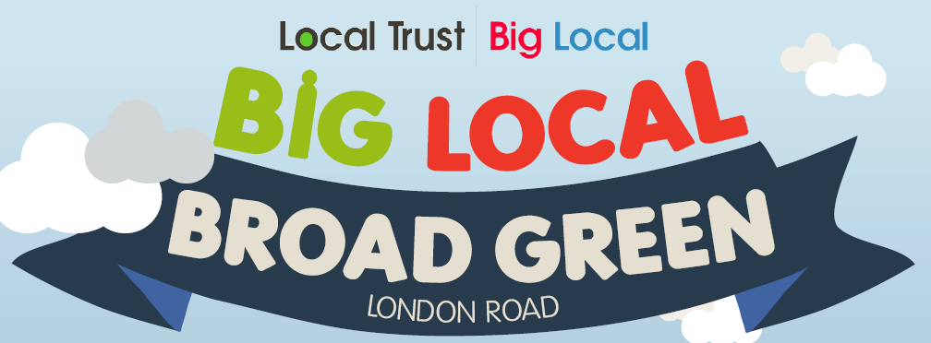
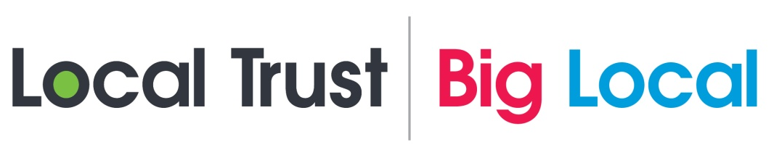

Invitation to Tender
Big Local Broad Green - Locally Trusted Organisation
- Advertisement & Summary
Big Local Broad Green (London Road area of LB Croydon), wishes to appoint a local organisation to support its work. Big Local is a national programme under which 150 areas each receive £1m over 10 years to develop and deliver a resident led programme of activity.
The core functions of a Locally Trusted Organisation (LTO) is to enter into a grant agreement with the Local Trust) to receive and manage the grant of £1million as it comes through in phases in accordance with the agreed Big Local Plan.
Applications are welcome from organisations from all sectors. Key aspects of the role are to manage the finances of the programme on behalf of the National Lottery and provide a range of support and assistance to the resident led Partnership Board.
Deadline for submissions 12.00 Friday 18th December 2015. For further details and application pack please contact Matt Freidson, Big Local Rep at matt.freidson@gmail.com or visit http://www.biglocalbroadgreen.co.uk/.

- Background
Big Local is an innovative national programme under which 150 areas each receive £1m over 10 years to develop and deliver a resident led programme of activity. See http://www.localtrust.org.uk/big-local/ for more details.
Big Local aims to achieve the following outcomes:
- communities will be better able to identify local needs and take action in response to them
- people will have increased skills and confidence so that they can continue to identify and respond to local needs in the future
- the community will make a difference to the needs it prioritises
- people will feel that their area is an even better place to live.
Big Local Broad Green (London Road area of LB Croydon) has established a robust resident partnership with the support of its Big Local representative, Matt Freidson, and Paul Macey of Croydon Voluntary Action (CVA). It has drawn up a vision for the area, elected an Interim Chair and Vice-Chair, and collated views from residents, local businesses and other relevant stakeholders.
We have until 31 March 2016 to develop our plan for how we want to spend the £1million over 10 years, and want to begin delivering as soon as the Plan is approved by the Local Trust (estimated to be May/June 2016).
- Role of the Locally Trusted Organisation (LTO)
The main functions of an LTO is to enter into a grant agreement with the national Big Local organisation (called the Local Trust) to receive and manage the grant of £1million in accordance with the agreed Big Local Plan. It does not direct or decide on the work itself; this is the role of the resident-led Partnership. The LTO’s core work entails:

Financial
- Draw down funds from the £1,000,000 and hold those funds on behalf of the resident-led partnership.
- Fulfil contractual obligations on behalf of the partnership, re spending of funds drawn down (i.e. any contracts will be between the third party and the LTO, purchasing, promotions, etc.)
- Manage and distribute grants/tenders/commissions to support local activities
- Manage relevant matters as declarations of interest, insurance cover, licences etc.
- Ensure spending of the funds meets the four Big Lottery objectives and are in accordance with the area’s Big Local Plan
- Ensure that decisions and procedures meet the requirements of Local Trust to ensure transparency, accountability and best practices
Reporting
- Provide financial reports to the partnership
- Report to Local Trust in accordance with the terms and conditions of the grant, using the monitoring forms provided
For these core functions, the LTO will receive a fee of 5% of any funds drawn down for which the LTO is responsible for delivering (i.e. if £100,000 is drawn down per year, the LTO will receive £5,000). This fee is in addition to the £1m.

Broad Green Big Local seeks an LTO to take on the following additional functions:
Personnel
- Employ any staff necessary to undertake the Big Local Plan and support the partnership
- Provide office space and resources for partnership members and staff
Support The Partnership
- Organise partnership meetings & resident/stakeholder meetings/consultations; support and service these meetings via agendas, papers, minutes etc.
- Hold a non-voting advisory role on the partnership
- Create and maintain contact lists
- Work with the partnership to review progress on delivering the Big Local Plan and evaluate impact in terms of its main aims
- Provide or broker training and support for the partnership and its working groups

Costs for these functions must be identified within your application and agreed for inclusion in the Big Local Plan.

You can see the Local Trust Terms & Conditions here.
- Criteria
Locally trusted organisations in Big Local areas include: housing associations, parish councils, local businesses, charities, voluntary groups, community voluntary services, community foundations, trusts and other funders, community groups, schools, credit unions, churches and a GP surgery.

An organisation does not have to be a charity to be an LTO, but as a grant the Big Local fund needs to be considered a protected fund for accounting purposes. Where necessary, its deployment will be subject to Big Local policies and procedures, not those of the LTO.
Being already involved in Broad Green Big Local will not bar any organisation from applying, but appropriate declarations of interest will be expected as part of your submission.
To be considered as an LTO, your organisation must be:
- Legally constituted and able to fufil the LTO role within the objects on your governing document
- Have a stable financial position as well as experience and capability to administer and account for the funding
- Have a bank account in the name of the organisation with at least two signatories who are not related to one another or reside at the same address

- Area of Benefit
The map below shows the area remit as originally defined by Local Trust. The Broad Green Big Local partnership aims to slightly amend these boundaries by December 2015, but the below represents the primary area of benefit.
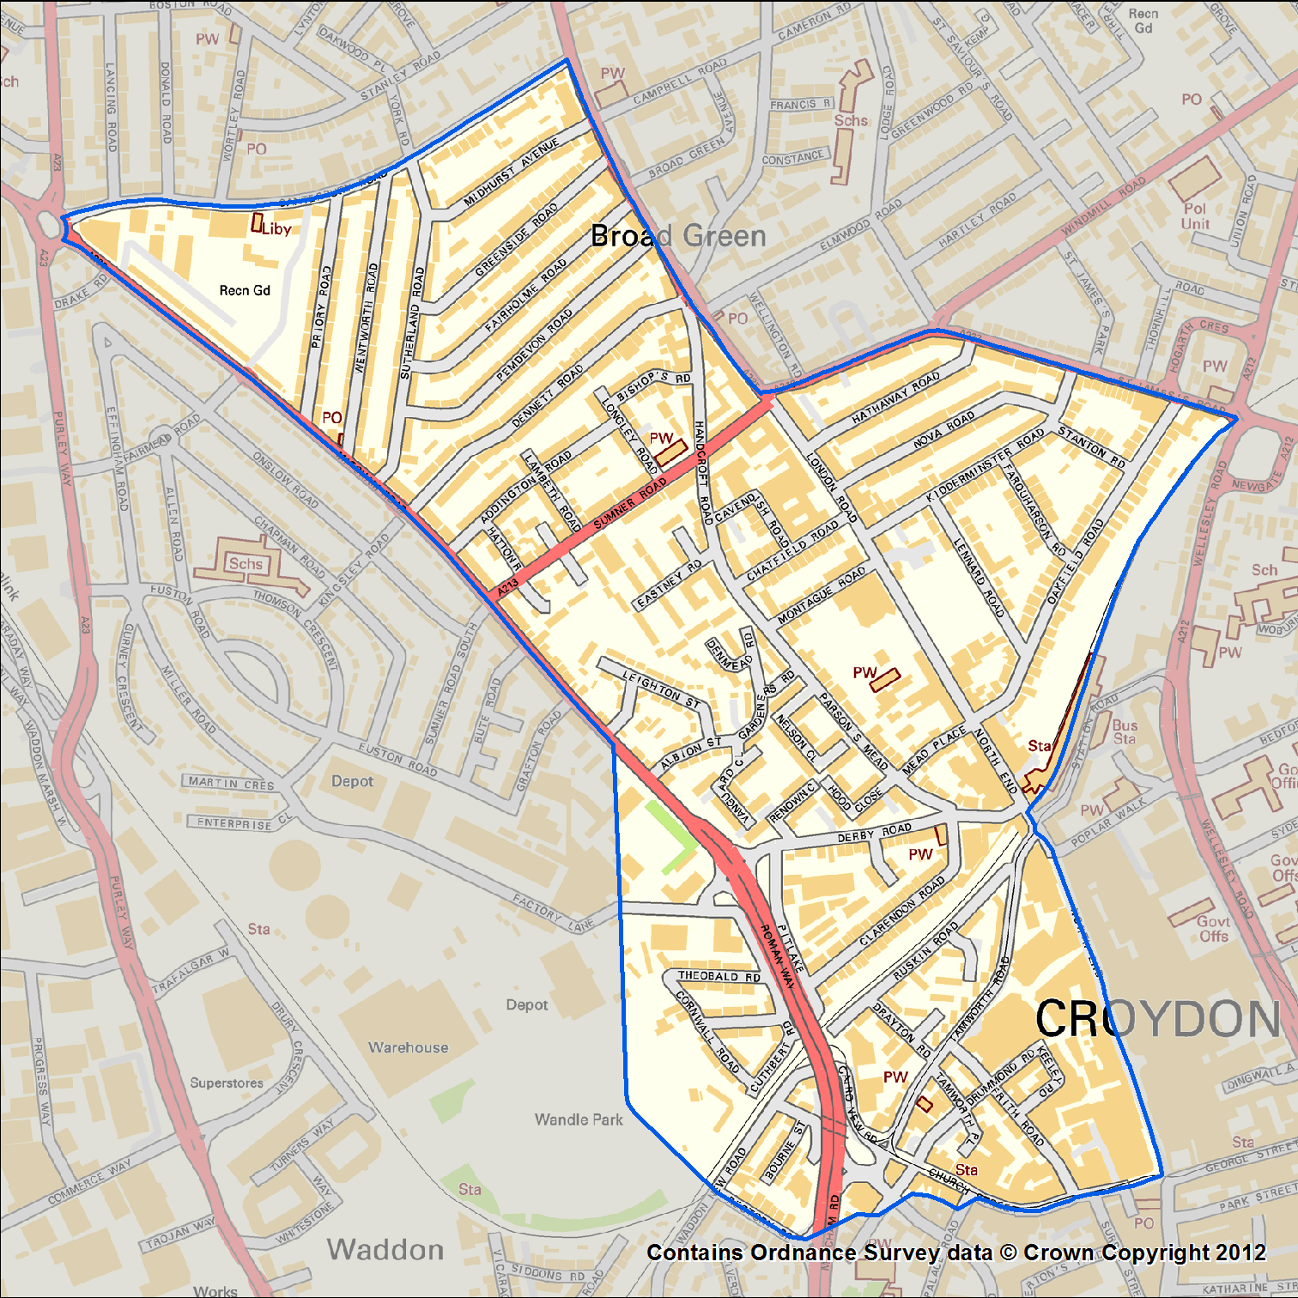
- Key Contract Terms
Funding
- A total fee of a maximum of the annual Big Local Plan budget will be paid by Local Trust to deliver the role. This is in addition to the £1m Broad Green Big Local receives.
- At £1 million over ten years this is approximately £100,000/year, or £5,000 for the LTO. However, many/most Big Local areas front-load budgets in earlier years.
- Any costs outside this will need to be negotiated between the partnership and the LTO and budgeted from within the area’s £1m. Organisations that are simply considering this role from an earning perspective may wish to consider this.
- We want to work with organisation/s that are highly committed to the aims of the Big Local and excited by the innovation and the opportunities that it offers.
- If an organisation can offer input /resources in kid as part of their submission for the role of LTO, so much the better, but this is not a requirement.
Length of Term
- Big Local funding is normally agreed for each year in advance or for the term of the detailed Plan. In Year 1 the plan shall be for one year, likely moving to two or three year plans thereafter.
- The LTO and the partnership will agree to a contract for three years (but can be terminated on 3 months’ notice), following which the role may be renewed or re-advertised.
- Therefore there is potential but not a commitment from either the Partnership or the LTO for a ten year contract. Key to continuation will be a good working relationship.
- Submission to Tender
Your submission will be judged against the following criteria:
- Staff & organisational capacity to deliver the LTO tasks
- Experience of successful work in Broad Green and/or similar local communities.
- Evidence of previous experience or potential to carry out similar roles to those involved here.
- Understanding of and commitment to the desired Big Local outcomes and features—and what this means in practice in Broad Green.
- Understanding of the issues faced by Broad Green/London Road area
- Cost and value added, including any additional resources that you might bring which may help us to achieve our aims.

Proposal: Please send us an outline proposal on no more than 5 sides of A4, 10 point or above, outlining in summary how you meet the above criteria.

Supporting information: In addition to your proposal, please supply:
- Summary CV’s and/or information about key existing or planned staff that you would allocate to the roles involved.
- Copies of your most recent two years of audited annual accounts.
- Budget or management account showing anticipated income and expenditure for 2015-16.
- Declaration of any interests relevant to this selection process.
- The names and contact details of two referees, preferably from customers or partners for whom you have performed similar tasks.
- Confirmation that your organisation:
  - is legally constituted and empowered to carry out the tasks involved.
  - holds adequate and appropriate insurance cover to undertake the roles required.
  - possesses relevant policies and procedures for safeguarding, equalities and any other matters that you consider relevant to these roles.
Further information: Contact Matt Freidson, Big Local rep on 07852 868 065 or matt.freidson@gmail.com.

Please email submissions to matt.freidson@gmail.com.
Deadline for submissions: 12pm, 23 December 2015

- Selection Process
Invitation to Tender issued | 20 November
Closing date for submissions | 12pm, 23 December
Assessment, shortlisting & contacting referees | 4-15 January
Partnership interview – with current Partnership members | 18-29 Jan
Technical interview – with Interim Chair, Vice-Chairs, Big Local rep and 1-3 additional reps TBD | 18-29 Jan
Decision | 1 Feb
Issuance of contract – upon drawdown of additional Pathways funding or endorsement of Plan by Local Trust | TBD but no later than 1 May 2016

