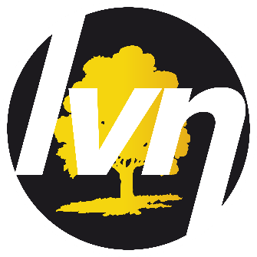
Promote Your Youth Opportunities on the
London Village Network
One-stop Digital App

LVN TERMS & CONDITIONS
Prior to being issued a unique app listings login, end users must agree to the following term and conditions.
On behalf of (insert name of organisation) ……………………………………………………….,
I, the undersigned, declare that:

- We will only use the LVN app to promote positive opportunities to young people,
- We will not disclose our unique login and/or password to any 3rd party organisation to enable them to upload their events and opportunities,
- We will only use a young person’s personal data in connection with an event or activity they have identified interest in. We will only contact young people for other reasons if they have given permission for us to do so.
- We will only use the LVN unique log in code for a period of 1 year (from signed date).

ORGANISATION NAME: ………………..…………………………………………………………

ADDRESS: ……………………………………………………………………..……………………

………………………………………………………………… Postcode:………………...……….

SIGNED BY (PRINT NAME) ………………………………………………………………..……..

SIGNATURE ……………………………………………………. DATE: …….. /……… /……

