


If Only I’d Known: Caring for Someone with Dementia
Seven individual two-hour workshops

These seven workshops are for carers of people who have already received a diagnosis of dementia or people who think someone they care about may have dementia.

They have been co-produced by carers and ex-carers of people with dementia working alongside staff from SLaM’s Older Adult services.

Each session covers a different topic and you can enrol in one, several or all of the workshops and they are all free of charge.

Date | Time | Workshop theme
Wednesday 2nd November 2016 | 2pm-4pm | Talking about Dementia
Wednesday 9th November 2016 | 2pm-4pm | Dealing with Social Care
Wednesday 16st November 2016 | 2pm-4pm | Health of the Person with Dementia – Physical
Wednesday 23rd November 2016 | 2pm-4pm | Health of the Person with Dementia – Emotional
Wednesday 30th  November | 2pm-4pm | Care for the Carer
Wednesday 7th December 2016 | 2pm-4pm | The Legal Side of Things
Wednesday 14th December2016 | 2pm-4pm | Assistive Technology and Question/Answer Session
LOCATION:
Carers Support Centre
24 George Street
Croydon
CR0 1PB
Venue Detail 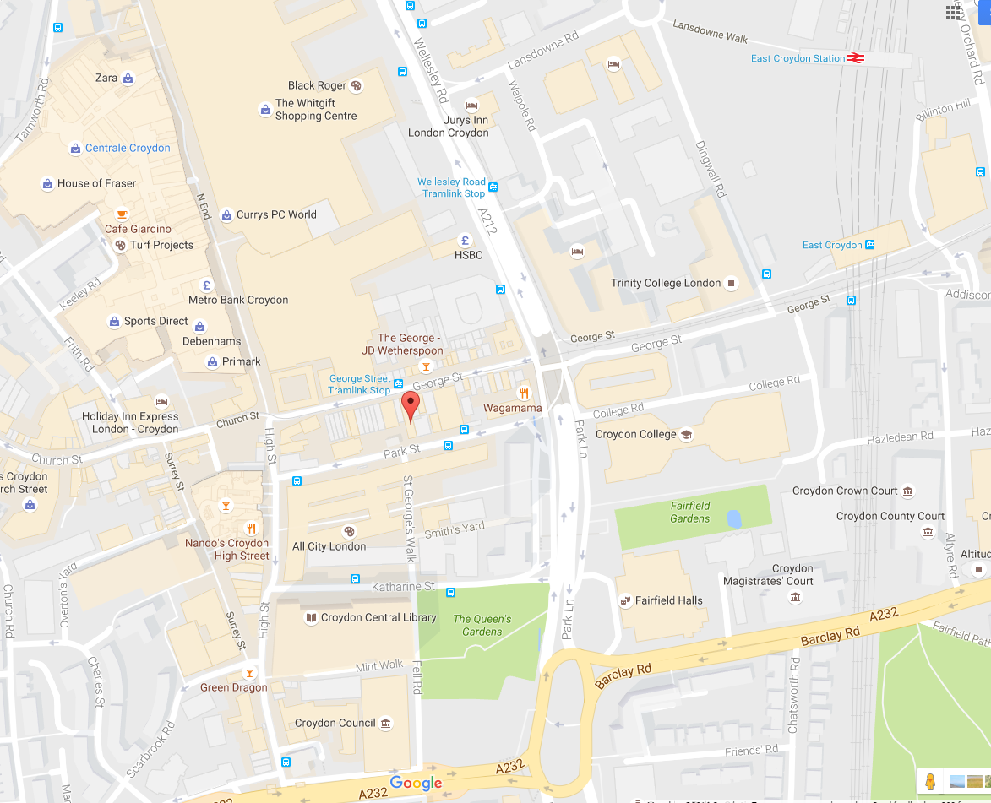
___________________________________________________________
Carers Support Centre
24 George Street
Croydon
CR0 1PB

Travel by bus: 264, 468, 50, 166, 455, 60, and 109
Nearest Tram: George Street
Nearest Train station: East Croydon station is a 7 minute walk and West Croydon station an 11 minute walk from the Centre.
To Enrol Contact:
Nirusha Nicholas – Recovery and Engagement Worker - Carers
Tel: 020 3228 1625
Email: nirusha.nicholas@slam.nhs.uk

